杨时平（硕士导师）简历

**1. 导师的个人情况概括**

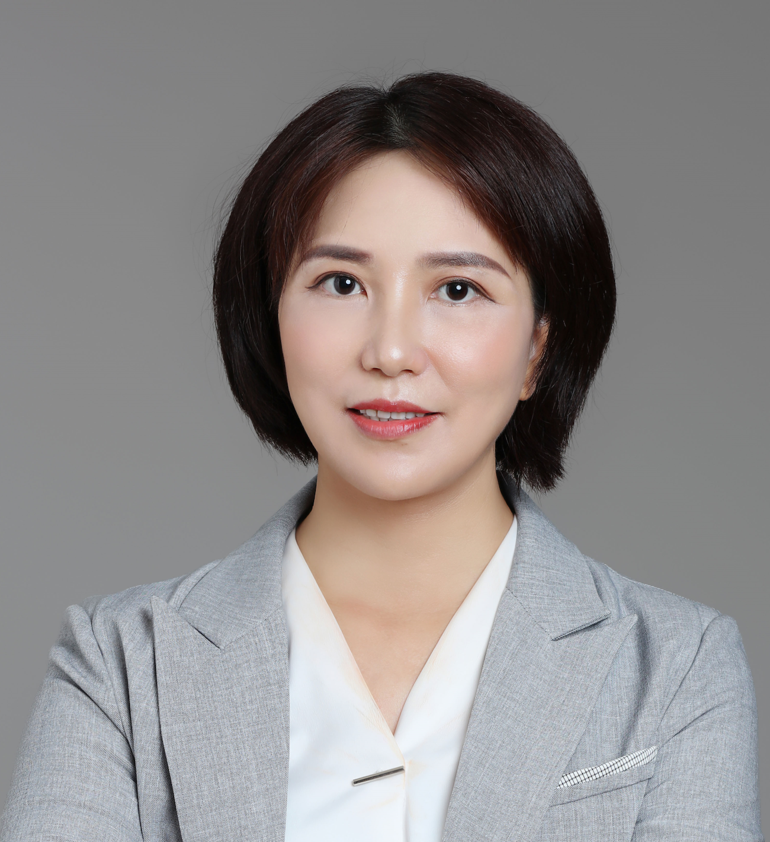

**姓 名：**杨 时 平 **性 别**： 女

**职 称：**副主任医师  **学 位：**博士研究生

**籍 贯**：海南 **手 机：**18976460313

**专 业**：肿瘤放射治疗学 **邮 箱：** shipingyang1982@163.com

**2. 研究方向**

1）鼻咽癌研究方向（这部分内容正在与中肿的实验研究部进行合作）

1. 早期诊断：外泌体circRNA作为鼻咽癌肿瘤标志物在诊疗中的应用
2. 放疗增敏作用：铁死亡调控分子在鼻咽癌放疗敏感性中的作用及机制

2）乳腺癌研究方向

1. CirRNA在乳腺癌浸润转移中的作用及其机制研究
2. 区域淋巴结的放疗对T3～4N0M0乳腺癌患者的生存研究；
3. 首发Ⅳ期乳腺癌术后放疗是否有生存获益

**3. 发表的学术论文和专著（第一作者或通讯）**

1. Yang SP, Rao MY, Chen QS, Zhou P, Lian CL, Wu SG. Causes of Death in Long-Term Nasopharyngeal Carcinoma Survivors. Front Public Health. 2022 Jul 7;10:912843. doi: 10.3389/fpubh.2022.912843. PMID: 35875003; PMCID: PMC9301133.(第一作者, IF 6.461)
2. Shi-Ping Yang, Ping Zhou, Chen-Lu Lian, Zhen-Yu He, San-Gang Wu. The Predictive Effect of the 8th AJCC Pathological Prognostic Staging on the Benefit of Postmastectomy Radiotherapy in N2/N3 Breast Cancer. Breast Cancer: Targets and Therapy.2022:14 133–144. (第一作者, IF 5.088 )
3. **Yang SP**, Su HL, Chen XB, Hua L, Chen JX, Hu M, Lei J, **Wu SG**, Zhou J. Long-Term Survival Among Histological Subtypes in Advanced Epithelial Ovarian Cancer: Population-Based Study Using the Surveillance, Epidemiology, and End Results Database. JIMR Public Health and Surveillance. 2021 Nov 17;7(11):e25976. doi: 10.2196/25976. PMID: 34787583.(第一作者, IF 4.112)
4. **Yang SP,** Li JF, Zhou P, Lian CL, Chen DX, Li ZJ, Wu SG. Biopsy of cervical lymph node does not impact the survival of nasopharyngeal carcinoma. Cancer Med. 2021 Oct;10(19):6687-6696. doi: 10.1002/.(第一作者,IF 14.552)
5. Li G, Yao J, Chen J, Cai B, Lin X, Chen Z, Chen J, Wang H, **Yang S**. The Survival Effect of Chest Wall With or Without Regional Lymphatic Radiotherapy for Breast Cancer Patients With T3~4N0M0. Front Oncol. 2021 Jul 12;11:653831. (通讯作者 IF 6.243 )
6. **Yang SP**, Yao J, Zhou P, Lian CL, Wang J, Fang MX, **Wu SG**. Adjuvant chemotherapy and survival outcome in node-negative breast cancer with a 21-gene recurrence score of 26-30. Future Oncol. 2021 Jun;17(17):2183-2192.(第一作者，IF 3.404).
7. Wang J(#), **Yang SP**(#), Zhou P, Lian CL, Lei J, Hua L, He ZY, Wu SG. Additional radiotherapy to breast-conserving surgery is an optional treatment for de novo stage IV breast cancer: A population-based analysis. Cancer Med. 2021 Feb 14.10(5):1634-1643. (共同第一作者,IF 4.452)
8. Wu SG(#), **Yang SP**(#), Zhang WW, Wang J, Lian CL, Chen YX, He ZY. The longitudinal risk of mortality between invasive ductal carcinoma and metaplastic breast carcinoma. Sci Rep. 2020 Dec 16;10(1):22070.( 共同第一作者, IF 4.379)
9. Li G, Yao J, Wu T, Chen Y, Wang Z, Wang Y, Wang F, Zhong R, **Yang S**. Triple metachronous primary cancer of uterus, colon, and breast cancer: A case report and review of the literature. Medicine (Baltimore). 2020 Aug 21; 99(34):e21764. (通讯作者, IF 1.889)
10. **Shiping Yang**, Xiaoling Fu, Guang Huang, Junni Chen, Shishi Luo, Zhenping Wang, Fanzhong Kong, Gang Wu, Shaomin Lin, Fen Wang, Longhua Chen. The impact of the interval between the induction of chemotherapy and radiotherapy in the survival of patients with nasopharyngeal carcinoma. Cancer Management and Research. 2019 Mar 22. 11: 2313–2320.(第一作者, IF 3.989)
11. Xu C(#), **Yang S**P(#), Zhang Y, Tang LL, Zhou GQ, Liu X, Mao YP, Guo R, Li WF, Chen L, Lin AH, Sun Y, Ma J. Neutropenia during the First Cycle of Induction Chemotherapy Is Prognostic for Poor Survival in Locoregionally Advanced Nasopharyngeal Carcinoma: A Real-World Study in an Endemic Area. Cancer Res Treat. 2018 Jul;50(3):777-790. (共同第一作者, IF 4.679)
12. Guanqiao Li(#), **Shiping Yang**(#), Jia Yao(#), Zhenping Wang, Guangyu Yao, Mingfeng Liu and Changsheng Ye. Invasive micropapillary carcinoma of the breast had poor clinical characteristics, but showed no difference in prognosis compared with invasive ductal carcinoma. [World Journal of Surgical Oncology.](https://www.ncbi.nlm.nih.gov/pubmed/?term=Invasive+micropapillary+carcinoma+of+the+guanqiao+li" \o "World journal of surgical oncology.) 2016 August; 14(1): 207. (共同第一作者 IF: 2.754)
13. Chen, Jingxin(#); **Yang, Shiping**(#); Chen, Jimin; Liao, Tianan; Deng, Wei; Li, Weizhong(*). Microcystic adnexal carcinoma in a non-Caucasian patient: A case report and review of the literature. Oncol Lett. 2016 Apr;11(4):2471-2474. Epub 2016 Feb 17. (共同第一作者 IF:2.967)
14. Li G, Zhong X, Yao J, Chen J, Wang M, Liu H, **Yang S**(*). Secretory breast carcinoma in a 41-year-old man with long-term follow-up: a special report. Future Oncol. 2015;11(12):1767-73. (通讯作者 IF:3.404)
15. Li G, Chen J, Zhang S, Lin J, Kong F, Cai F, **Yang S**(*). Adenoid cystic carcinoma of the larynx: A report of two cases. Oncol Lett. 2015 Oct;10(4):2303-2306. (通讯作者 IF:2.967)
16. Tang P(#), **Yang S**(#), Zhong X, Yao J, Zhang Y, Dong H, Li G. Breast adenoid cystic carcinoma in a 19-year-old man: a case report and review of the literature. World J Surg Oncol. 2015 Feb 6;13:19. （共同第一作者 IF:2.754)
17. **Yang S**, Lin S, Fu Q, Cai B, Kong F, Huang G, Li F, Wang H. The effect of adjuvant chemotherapy on survival in patients with residual nasopharyngeal carcinoma after undergoing concurrent chemoradiotherapy. PLoS One. 2015 Mar 23;10(3):e0120019. (第一作者 IF:3.240)
18. **Yang S**, Wu J, Zuo Y, Tan L, Jia H, Yan H, Zhu X, Zeng M, Ma J, Huang W. ZD6474, a Small Molecule Tyrosine Kinase Inhibitor, Potentiates the Anti-Tumor and Anti-Metastasis Effects of Radiation for Human Nasopharyngeal Carcinoma. Curr Cancer Drug Targets. 2010 Sep;10(6):611-22. (第一作者, IF 3.428)
19. **获得的学术成果奖励（标注名次）**

无

**5. 获得的发明专利（标注名次）**

2022-04-19第一负责人 实用新型专利 “一种具有适形功能的补偿物”ZL2021 2 2551685.7

**6. 主持过的科研项目（项目名称；项目编号；级别；经费；起止日期）**

1. 海南省自然科学基金青年项目，No: 819QN345, CirUBAP2在乳腺癌浸润转移中的作用及其机制研究。项目主持人：杨时平 在研 2019-03-27~ 2021-12-31
2. 海南省重点研发社会发展项目 ZDYF2022SHFZ130. SCMH1及其来源的环状RNA分子调控乳腺癌进程及分子机制的研究 30万，2022.3.16～2024.3.16， 主持人：杨时平 在研

**7. 获得的学术荣誉**

1. 海南省自然科学优秀论文二等奖;
2. 南海名家系列第二批“南海名家”青年项目培养对象;
3. 2020年获得首批海南省消化系统恶性肿瘤“双百”人才团队成员

**8. 学术兼职**

1. 中华医学会放射肿瘤治疗学分会乳腺癌学组 委员、
2. 中国研究型医院学会放疗专委会 委员、
3. 中国抗癌协会肿瘤热疗专委会 青年委员、
4. 中国装备协会放疗装备与技术分会 委员
5. 海南省医学会放射肿瘤学专委会 委员、
6. 海南省医师协会放射肿瘤学专业委员会 委员、
7. 海南省乳腺防治专业委员会 常委、
8. 海南省抗癌协会乳腺癌青年专业委员会 常委